EMAX ONLAYS - INFORMED CONSENT

Dear (Patient Name) (DoB)

It was a pleasure meeting with you on (date) for your dental examination.

I am writing to provide further information about your upcoming treatment appointment with myself involving restoration of the tooth, namely (specify tooth, e.g. lower left first molar, LL6) with a lithium disilicate (tooth coloured) onlay.

Your understanding of the procedure and what is involved is essential, and within this letter I will outline all the information you will need. An estimate has been provided to you confirming the cost for the onlay.

The existing situation
The tooth in question has (decay, crack, an existing old large restoration that is leaking, previously been root filled and requires cuspal coverage …insert the relevant current situation).

A clinical photo and x-ray of your tooth is attached for your reference.

Treatment options:
The following options were discussed with you.
- Do nothing.
  - If you choose to do nothing, there is a chance that:
    - the existing cavity within the tooth will become bigger.
    - the existing restoration will fail, and the bacteria will continue to thrive and eat away more of the tooth structure.
    - your pain currently experienced due to ‘cracked tooth’ will be exacerbated and result in further pain, infection, swelling and abscess. The crack may also propagate and get worse leaving the tooth unrestorable and possibly also requiring root canal treatment.
    - A wall of the tooth may fracture, leaving the tooth unrestorable.
- Restore the tooth with an onlay. In your situation, we have decided this is the best treatment choice to restore and protect your tooth.

What is an e.max Onlay?
An onlay is a type of tooth coloured indirect restoration (custom made by the laboratory) used to protect the tooth from further deterioration. Unlike traditional fillings, which are placed directly into the prepared cavity, an e.max onlay is constructed outside of the mouth and then bonded onto the tooth surface. Onlays are less destructive than dental crowns and are designed preserve as much natural tooth structure as possible, whilst restoring the tooth's function and appearance.

What is the process for having an onlay?
The following steps will need to be undertaken for construction of an onlay. In most instances, there will be two appointments that will be required.
- At the first appointment, we will prepare the tooth for the onlay, record a shade, impressions or scans to be sent to the laboratory and make a temporary onlay.
- The second appointment would be for fitting the onlay. The fit of the onlay is approximately 2-3 weeks after the preparation appointment, as it takes this time for the onlay to be constructed by the laboratory.
The detailed process is as follows:
- Confirmation of your medical history. If there are any changes to your medical history, please let us know prior to the appointment;
- Local anesthetic (a small injection) may be required to anesthetise the gum and tooth;
- Shade selection. The closest possible shade to your existing tooth will be chosen, alongside any relevant clinical photographs;
- Removal of any old previous restoration, decay or cracks;
- Preparation and modification of the existing tooth structure to prepare it for the indirect onlay restoration;
- Application of a protective sheet over the tooth to isolate it from the saliva in your mouth.
  - If required, the tooth may require building up/ restoring directly with composite filling material to provide core strength.
- Cleaning the tooth and sealing the exposed tooth tissue with a bonding agent;
- Taking records and moulds of the prepared tooth for the laboratory to construct the onlay;
- Construction of a temporary onlay, which will be cemented on the day. Following this, it will then take the lab 2-3 weeks to construct the definitive permanent onlay which will be cemented at the next onlay fit appointment;
- The permanent onlay will be bonded onto the prepared tooth after thorough checks the fit is acceptable.

Common or expected Risks:
- Sensitivity of teeth
  - Regardless of which material is utilised, the teeth treated may remain mildly sensitive after completion of treatment.
  - If the pain is severe or extreme sensitivity persists for an extended period of time, or if the symptoms are prolonged, please contact the practice and the tooth will be tested to see if it requires a root canal treatment (If it has not already had root canal treatment).
    - With some teeth with which may exhibit deep decay or a crack prior to placement of the permanent onlay, a temporary onlay may be placed for an extended period of time to ensure the tooth remains asymptomatic following the preparation and modification of the tooth procedure.
    - There is a chance that teeth prepared may require root canal treatment in the near or distant future. Should this be necessary, a new estimate for the root canal treatment will be provided.
- Risk of failure
  - There are risks which may occur even though care and diligence will be exercised during your treatment. These risks include possible unsuccessful results and/or failure. This is more common in teeth that have large cavities and cracks.
    - Extraction of the tooth may be necessary and if this is deemed necessary, then a new estimate for the root canal treatment will be provided.
- Injury to nerves
  - In any type of dental work, there is a possibility of injury to the nerves of the lips, jaws, teeth, tongue, or other oral or facial tissues from any dental treatment, particularly those involving the administration of local anesthetics. The resulting numbness, which could occur is usually temporary, but in rare instances could be permanent.
- Aesthetics or appearance
  - When tooth coloured ceramic onlays are placed, every effort will be made to closely approximate the natural tooth colour. However, achieving an exact colour match with the natural remaining tooth tissue may be challenging in some cases.
  - Every effort will be made to ensure a seamless blend with the surrounding dentition, however as the margins of onlays usually lie above the gums there may be a chance that there is a visible junction between the placed restoration and tooth.
  - Over a period of time, because of mouth fluids, different foods eaten or drinks, smoking, clenching and grinding habits etc. the underlying tooth structure may also change colour, increasing the visibility of the margin between the restoration placed and the tooth. The dentist has no control over these factors.
- Breakage, dislodgement or bond failure
  - Due to extreme chewing pressures or other traumatic forces, it is possible for onlays to be dislodged or fractured resulting in leakage and recurrent decay. The dentist has no control over these factors.
- Longevity of Onlays
  - There are many variables that determine “how long” onlays can be expected to last. Among these are some of the factors mentioned in preceding paragraphs.
  - In addition, general health, good oral hygiene, regular dental check-ups, and diet can affect longevity. Because of this, no guarantees can be made or assumed to be made concerning how long your onlay will last. It is therefore imperative you maintain daily home cleaning (twice a day with an electric toothbrush, interdental cleaning with floss or interdental brushes twice a day) and see the hygienists as prescribed by your dentist.
  - In the presence of a crack, the onlay aims to reduce the propagation of the crack but does not necessarily eliminate the risk.

Other risks:
- Numbness from the anaesthetic – if used – lasting a few hours.
- Soreness of the gums lasting a few days
- Trauma to other parts of the mouth, including adjacent teeth, gums, cheeks, and tongue.
- Debonding of temporary restorations placed as interim measures between visits.
- Allergic reaction to something used during the procedure.

Case example
Here is an example of a case treated by myself recently showing an emax onlay.
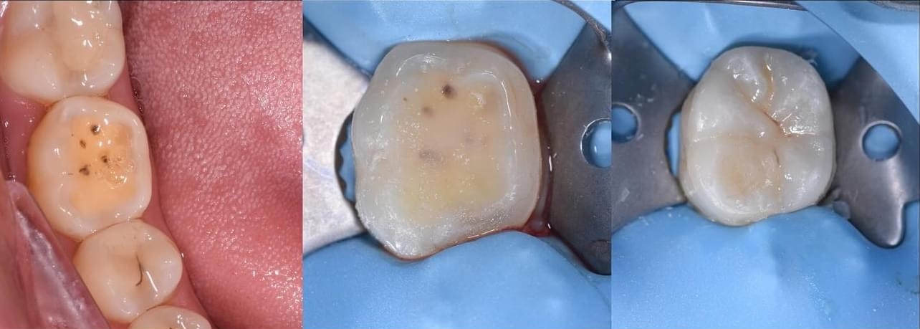
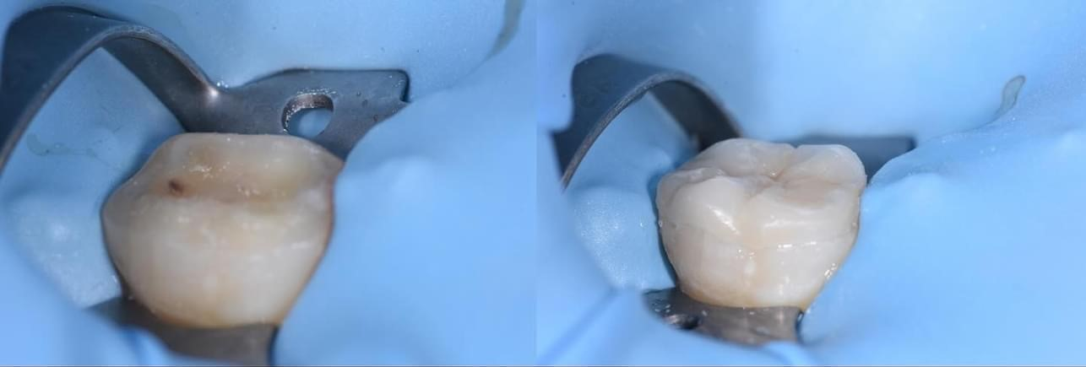

Concluding remarks
I hope the above information has helped in understanding the plan going forward. Kindly please return a signed copy of the attached consent form to our lovely reception team prior to your next appointment.

Please do not hesitate to contact us if you have any questions or concerns regarding the next appointment or any other aspect of your dental care. Thank you for entrusting us with your dental care, and we look forward to assisting you in achieving and maintaining your oral health.

Kind regards,

Dentist Name
Qualifications

Consent Form for Lithium Disilicate (E.MAX) Onlay

Procedure: Lithium Disilicate Onlay as outlined in the letter above

Nature of the Procedure:
The appointments may include, but is not limited to, the following procedures:
- Visual examination of the tooth.
- Diagnostic imaging, such as x-rays or other imaging modalities (if not already carried out).
- Pulp tests (to assess if tooth nerve is alive or not).
- Evaluation and removal/dismantling of existing dental restorations.
- Assessment of the structural integrity of the tooth.
- Examination of the surrounding tissues.
- Procedure to be carried out under local anaesthetic.
- Temporary restoration placement as interim measure between visits

Benefits of Lithium Disilicate (e.max) Onlays:
- To remove existing pathology associated with the tooth.
- To restore aesthetics, form and function
- Exceptional Strength – Lithium disilicate (e.Max) onlays once bonded onto the underlying tooth have high strength and durability, making them a reliable option for areas of the mouth subjected to heavy chewing forces.
- Aesthetics – e.Max material closely resembles natural tooth enamel in colour and translucency, providing a highly aesthetic and life-like restoration. This ensures that the onlay blends seamlessly with the surrounding teeth, maintaining a natural appearance.
- Conservative tooth preparation – the preparation process of e.max onlays allows for conservative tooth preparation, meaning less removal of healthy tooth structure compared to some alternative treatments like crowns. This preservation of tooth structure contributes to the long-term health and integrity of the tooth.
- Biocompatibility – Lithium disilicate (e.max) is biocompatible, meaning it is well-tolerated by the body and less likely to cause allergic reactions or adverse responses.
- Precision Fit –the onlay is custom-designed and fabricated to achieve a precise fit onto the tooth surface, ensuring optimal function and comfort.

Risks of Treatment:
- As outlined in the letter above

Alternative options:
- Do nothing: Leave and Monitor – this option would not address the problem and can lead to ongoing risk of disease including decay, crack propagation, pain, swelling, spread of infection, abscesses and eventual tooth loss.
  - It is important to note that we do not recommend you consider monitoring the tooth.
- Alternative materials for dental onlays including gold, and other ceramics. Each material has its own set of advantages and considerations, which can be discussed with your dentist based on your specific needs and preferences.

Financial Responsibility: I have been informed of the estimated costs, and I agree to make payment as required by the dental practice. I understand should the tooth require additional work in the future, there will associated costs with any further treatment required,

Questions and Concerns: I have had the opportunity to ask questions and my questions have been answered to my satisfaction.

Consent:
- I have read and understand the information provided in this consent form.
- I consent to undergo the treatment as described above.
- I understand:
  - I have the right to change my mind at any time, even after signing this form.
  - The risks of the procedure, alternative treatments, and the consequences of doing nothing have been explained.
  - I have been given a copy of this consent form and have had sufficient time to give my informed consent.
  - I must follow any post-operative instructions given to me.
  - By attending appointments and allowing treatment to be carried out shows I have consented to treatment.
  - I voluntarily accept the risks, including the risks of substantial harm if any that may be associated with any phase of this treatment in hopes of obtaining the desired outcome.
  - I have the right to seek a second opinion from another dentist at any time.
  - I understand that Dentistry is not an exact science and that, therefore, a reputable doctor cannot guarantee any specific results. No Guarantee or assurance has been given by my dentist of the expectations of results that may be achieved.

Patient’s Signature: ................................................................. Date.....................................

