DENTAL RESTORATIONS (FILLINGS) - COMPOSITE
INFORMED CONSENT

Dear (Patient Name) (DoB)

It was a pleasure meeting with you on (date) for your dental examination.

I am writing to provide further information about your upcoming treatment appointment with myself involving restoration of the tooth, namely (specify tooth, e.g. lower left first molar, LL6) with a composite resin filling material (tooth coloured).

Your understanding of the procedure and what is involved is essential, and within this letter I will outline all the information you will need. An estimate has been provided to you confirming the cost for the composite filling.

The existing situation
The tooth in question has (decay, crack, an existing old filling that leaking, insert the relevant current situation).

A clinical photo and x-ray of your tooth is attached for your reference.

Treatment options:
The following options were discussed with you
- Do nothing.
  - If you choose to do nothing, the cavity within the tooth will only grow bigger. This Is because the bacteria within the cavity continue to thrive and eat away more tooth structure.
  - This can result into untoward consequences like risk of future pain, infection, swelling and abscesses.
  - Pain is always a late symptom when the decay has spread close to the pulp (nerve chamber).
  - If the decay has already spread into the nerve, you will require root canal treatment and some teeth will subsequently require a crown placement after the root canal treatment.
  - If the decay grows deeper below the gum line, making the tooth unrestorable, the tooth will need to be extracted.
- To restore the tooth with a filling. In your situation, we have decided the best treatment choice is a composite resin filling material.

Material Choice for permanent filling:
Composite (white)
  - Advantages
    - Tooth coloured.
    - Bonded to the tooth which may add additional strength to the tooth
  - Disadvantages
    - Technique dependent and can take more time, skill and effort to complete than amalgam fillings.
    - Cannot be used in some clinical situations where the decay is deep and moisture control from saliva cannot be obtained.
    - More costly compared to amalgam fillings.
    - Over time can stain and do not maintain the same aesthetics as when first placed.
  - Risks
    - Of bond failure, chipping and breaking. The resulting leakage under the filling can lead to further spread of decay.

What happens on the day
The following steps will need to be undertaken on the day:
- Confirmation of your medical history. If there are any changes to your medical history, please let us know prior to the appointment.
- Shade selection. The closest possible shade to your existing tooth will be chosen.
- Application of local anaesthetic. You will feel a small prick in your gums
- Removal of any old restoration, decay or cracks.
- Application of a protective sheet over the tooth to isolate it from the saliva in your mouth
- Cleaning the tooth with a bur and bonding of the composite filling to the tooth
- Shaping and polishing
- The bite will be examined to ensure it align with the rest of the teeth.

Common or expected Risks:
- Sensitivity of teeth
  - Regardless of which material is utilised, the teeth treated may remain mildly sensitive after completion of treatment.
  - If the pain is severe or extreme sensitivity persists for an extended period of time, please contact the practice and the tooth will be tested to see if it requires a root canal treatment.
    - Whilst every tooth that needs a filling does not need a root canal treatment, some teeth with deep decay or crack may require root canal treatment in the near future or distant future.
    - Should this be necessary, a new estimate for the root canal treatment will be provided.
- Risk of failure
  - Regardless of which material is utilized, there are risks which may occur even though care and diligence will be exercised during your treatment. These risks include possible unsuccessful results and/or failure. This is more common in teeth that have large cavities that need a large filling.
  - You may therefore need an onlay or crown (cap) in the future to protect the tooth further.
    - Should this be necessary, a new estimate will be provided.

- Risks of root canal therapy
  - When any type of fillings are placed or replaced, the preparation of the teeth for fillings often necessitates the removal of tooth structure adequate to ensure that the diseased or otherwise compromised tooth structure provides sound tooth structure for placement of the restoration.
  - At times, this may lead to exposure or trauma to the underlying nerves and pulp tissue.
  - Should the pulp not heal, which is often exhibited by extreme sensitivity, pain or possible abscess, root canal treatment or extraction may be required.
  - It is important to remember that despite having the decay previously where the tooth may have been asymptomatic, injury to the nerves may have already been initiated by the bacteria and sealing the cavity with a filling may result in initiation of the symptoms.
  - Should this be necessary, a new estimate for the root canal treatment will be provided.

- Injury to nerves
  - In any type of dental work, there is a possibility of injury to the nerves of the lips, jaws, teeth, tongue, or other oral or facial tissues from any dental treatment, particularly those involving the administration of local anesthetics. The resulting numbness, which could occur is usually temporary, but in rare instances could be permanent.

- Aesthetics or appearance
  - When composite materials are used, every effort will be made to closely approximate the natural tooth color.
  - However, due to the fact that there are many factors which affect the shades of teeth, it may not be possible to exactly match the tooth shade.
  - Also, over a period of time, the composite fillings, because of mouth fluids, different foods eaten or drinks, smoking, etc. may cause the shade to change. The dentist has no control over these factors.

- Breakage, dislodgement or bond failure
  - Due to extreme chewing pressures or other traumatic forces, it is possible for fillings to be dislodged or fractured resulting in leakage and recurrent decay. The dentist has no control over these factors.

- Longevity of fillings
  - There are many variables that determine “how long” fillings can be expected to last. Among these are some of the factors mentioned in preceding paragraphs.
  - In addition, general health, good oral hygiene, regular dental checkups and diet can affect longevity. Because of this, no guarantees can be made or assumed to be made concerning how long fillings will last. It is therefore imperative you maintain daily home cleaning (twice a day with an electric tooth brush, interdental cleaning with floss or interdental brushes twice a day) and see the hygienists as prescribed by your dentist.

Other risks:
- Numbness from the anaesthetic – if used – lasting a few hours.
- Soreness of the gums lasting a few days
- Trauma to other parts of the mouth, including adjacent teeth, gums, cheeks and tongue.
- Difficulty restoring the tooth back to it’s original shape, which can result in difficulty cleaning the tooth. Sometimes a crown or onlay may be recommended as an alternative in this case.
- Allergic reaction to something used during the procedure.

Case example
I attach a case example of a recent case I had completed. During the appointment, we were able to follow the steps above to replace the leaking silver filling for a composite resin filling.

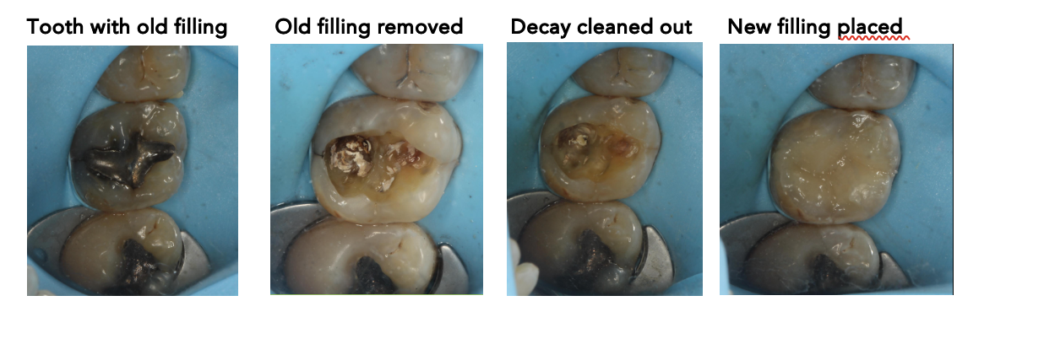
Concluding remarks
I hope the above information has helped in understanding the plan going forward. Kindly please return a signed copy of the attached consent form to our lovely reception team prior to your next appointment.

Please do not hesitate to contact us if you have any questions or concerns regarding the next appointment or any other aspect of your dental care. Thank you for entrusting us with your dental care, and we look forward to assisting you in achieving and maintaining your oral health.

Kind regards,

Dentist Name
Qualifications

Consent Form for Composite Filling

Procedure: Composite filling in a tooth as outlined in the letter above

Nature of the Procedure:
The appointment may include, but is not limited to, the following procedures:
- Visual examination of the tooth.
- Diagnostic imaging, such as x-rays or other imaging modalities (if not already carried out).
- Pulp tests (to assess if tooth nerve is alive or not).
- Evaluation and removal/dismantling of existing dental restorations.
- Assessment of the structural integrity of the tooth.
- Examination of the surrounding tissues.
- Procedure to be carried out under local anaesthetic.

Benefits of treatment:
- To remove existing pathology associated with the tooth
- To restore form and function

Risks of Treatment:
- As outlined in the letter above

Alternative options:
- Do nothing: Leave and Monitor – this option would not address the problem and can lead to ongoing risk of disease including decay, pain, swelling, spread of infection, abscesses and eventual tooth loss.
  - It is important to note that we do not recommend you consider monitoring the tooth

Financial Responsibility: I have been informed of the estimated costs, and I agree to make payment as required by the dental practice. I understand should the tooth require additional work in the future, there will associated costs with any further treatment required,

Questions and Concerns: I have had the opportunity to ask questions and my questions have been answered to my satisfaction.

Consent:
- I have read and understand the information provided in this consent form.
- I consent to undergo the treatment as described above.
- I understand:
  - I have the right to change my mind at any time, even after signing this form.
  - The risks of the procedure, alternative treatments, and the consequences of doing nothing have been explained.
  - I have been given a copy of this consent form and have had sufficient time to give my informed consent.
  - I must follow any post-operative instructions given to me.
  - By attending appointments and allowing treatment to be carried out shows I have consented to treatment.
  - I voluntarily accept the risks, including the risks of substantial harm if any that may be associated with any phase of this treatment in hopes of obtaining the desired outcome.
  - I have the right to seek a second opinion from another dentist at any time
  - I understand that Dentistry is not an exact science and that, therefore, a reputable doctor cannot guarantee any specific results. No Guarantee or assurance has been given by my dentist of the expectations of results that may be achieved.

Patient’s Signature: ................................................................. Date.....................................

