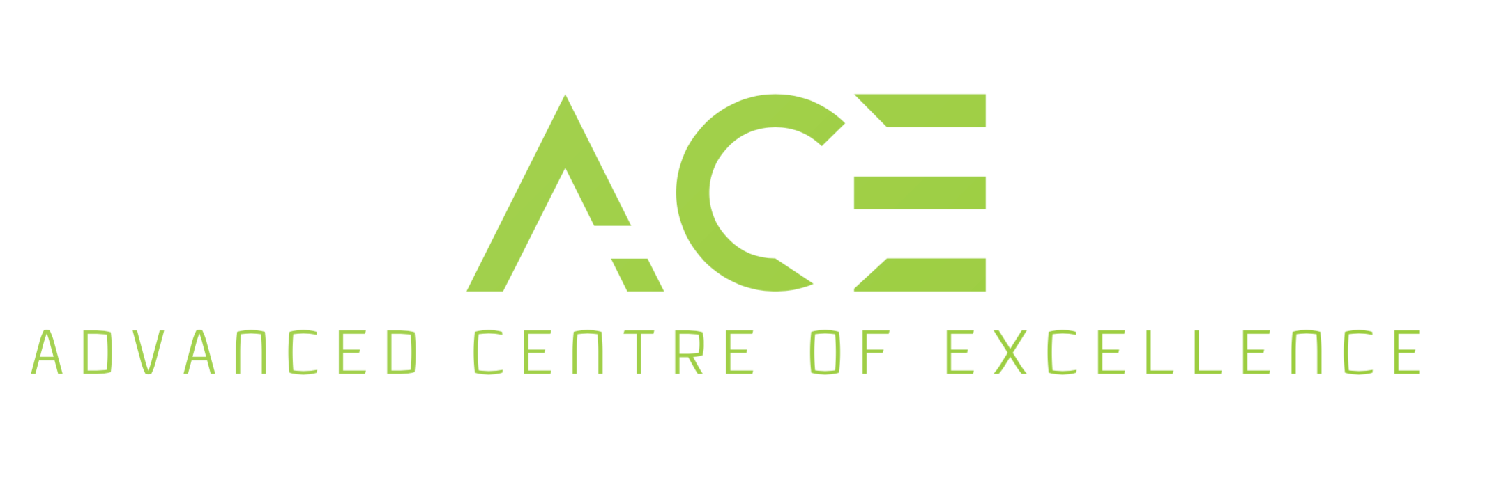
www.ace-courses.co.uk WhatsApp: +44 7849 862644 VAT reg number 361476294

Private & Confidential
Friday 07 July 2023

Dr (GP address)

Dear Dr.

Re:

I would be most grateful if you can review (Title) (Surname) on receipt of this letter to discuss the possibility of changing their calcium channel blocker medication for hypertension, if you deem this is appropriate, to a non-calcium channel blocker.

One of the side effects, in 50% of the population, associated with this medication is gingival enlargement. In (Title) (Surname)‘s case, the gingival enlargement is also resulting in plaque and calculus accumulation, difficulties to clean around their gums, and with deep pockets & progressive bone loss around the teeth.

In the interim, we have discussed the need for (Title) (Surname) to initiate their periodontal treatment with us.

I look forward to hearing from you following your review.

If you have any questions, please do not hesitate to contact me.

Kushal Gadhia
BDS (Bris. 2005) MFDS RCS Eng. MSc (Cons) FDS Rest Dent, RCS Eng.
Consultant in restorative Dentistry, Eastman Dental Hospital
Specialist in Periodontics, Prosthodontics, Endodontics and Restorative Dentistry
Special Interest in Dental Implantology
Clinical Director at Centre of Dental Excellence

