**SOCKET / RIDGE PRESERVATION**

**INFORMED CONSENT AND PATIENT INFORMATION LEAFLET**

Dear ***(Patient Name) (DoB)***

It was a pleasure meeting with you on ***(date)*** for your dental examination.

I am writing to provide further information about your upcoming treatment appointment with myself involving extraction of the tooth, namely ***(specify tooth, e.g. lower left first molar, LL6)*** combined with a simultaneous socket (bone) grafting procedure, which was your preferred treatment of choice. Your understanding of the procedure and what is involved is essential, and within this letter I will outline all the information you will need. An estimate has been provided to you confirming the costs.

**The existing situation**

The tooth in question has ***(decay, crack, an existing old large restoration that is leaking, previously been root filled and requires cuspal coverage …insert the relevant current situation).***  ***A clinical photo and x-ray of your tooth is attached for your reference.***

**Treatment options:**

The following options were discussed with you.

1. Do nothing.
   * If you choose to do nothing, there is a risk of the tooth flaring up and developing an abscess or sepsis.
2. Extraction of the tooth only, without the socket grafting
   * We know that this can cause significant resorption of the bone, both in width (thickness of the ridge) and height.
   * This can result in the final restoration (e.g. bridge or denture tooth) look un-aesthetic when compared to adjacent teeth
   * This may also mean the need for significant bone grafting, should you choose to consider a dental implant, in the future.
3. Extraction of the tooth with simultaneous socket grafting procedure

You have opted for option (3) above and I therefore attach further details for your consideration.

**What is Socket Grafting?**

Socket preservation is a surgical technique used to reduce bone loss following the extraction of the tooth and maintain the natural contours of the bone after a tooth is removed.

The procedure will be performed under local anaesthesia. After the tooth is carefully extracted, the socket will be cleaned and a bone graft material will be placed into the socket to fill the space left by the extracted tooth. A membrane or dressing may be placed over the bone graft to protect it during the healing process.

Stitches may be used to close the site and secure the bone graft.

Post-operative antibiotics will be given for a period of 7-10 days

It has been shown that by placing a bone graft within the extraction socket, one can expect to preserve about 70% of the bony and soft tissue (gum) architecture in the site. In doing so, there is less shrinkage of the associated gums and underlying bone, compared to when no socket grafting procedure is undertaken.

The benefits can be summarised as follows:

* Maintaining bone volume: Preserves the width and height of the jawbone.
* Helps maintain natural jawbone structure and appearance.
* Preparation for Future Procedures: Provides a stable foundation for future dental implants, bridges, or dentures.

**Types of Bone Graft used:**

The grafting materials may include one or a combination of the below. If you have any personal or religious reasons to avoid certain graft materials, please do bring this to our attention at least 7 days before the procedure, so that we can order alternative materials in time for your treatment. This is sometimes difficult to predict until we assess the socket after extraction.

* Xenograft (derived from animal sources, e.g., bovine (cow) or porcine (pig))
* Allograft (human donor tissue)
* Synthetic bone substitutes (man-made materials)

Different types of graft materials may have different indications which would have been discussed with you at length at your last appointment.

**A diagram showing how socket grafting is undertaken**

The images below show the stages of socket grafting. In some cases the membrane is not required, which can only be assessed after the tooth has been extracted.

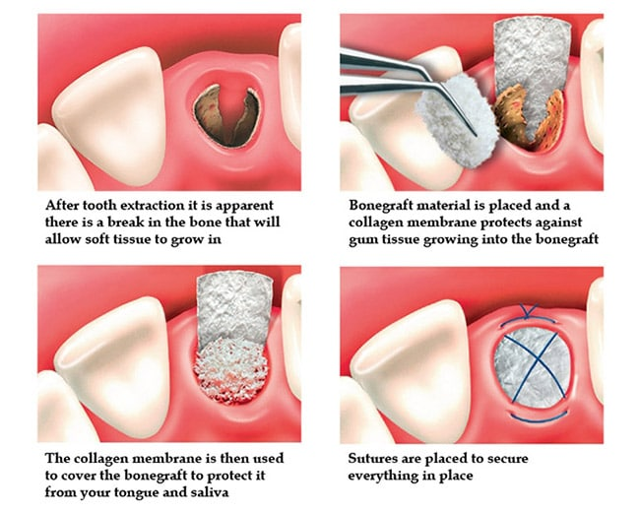

*(image taken from google images for illustration purposes)*

**Common or expected Risks:**

Albeit low, and as with any surgical procedure, some risks and potential complications may occur, including but not limited to:

* Infection: There is a risk of infection at the graft site if you don't keep the area clean or trap debris.
* Bleeding: Prolonged or excessive bleeding may occur.
* Swelling and Bruising: Temporary swelling and bruising around the surgical site.
* Damage to adjacent teeth during extraction procedure.
* Bone Graft Failure: The graft material may fail to integrate with the surrounding bone.
* Pain or Discomfort: Pain, sensitivity, or discomfort in the surgical area.
* Nerve Damage: Although rare, there is a risk of nerve injury resulting in temporary or permanent numbness or tingling.
* Allergic Reactions: Possible allergic reactions to anaesthesia, medications, or graft materials.
* Delayed Healing

**Other risks:**

* Numbness from the anaesthetic, lasting a few hours.
* Soreness of the gums lasting a few days
* Trauma to other parts of the mouth, including adjacent teeth, gums, cheeks, and tongue.
* Allergic reaction to something used during the procedure.

Additional bone grafting may be required in the future during procedures like implant placement.

**Patient Behaviours That May Increase Complications:** Certain behaviours may increase the likelihood of complications after the procedure, including but not limited to:

* Smoking or using tobacco products
* Poor oral hygiene or neglecting post-operative care instructions
* Excessive physical activity or strain following the procedure
* Failure to attend follow-up appointments
* Inadequate nutrition or hydration
* Use of certain medications or supplements without consulting your provider

**Case example**

**Here is an example of a case treated by myself recently showing socket grafting and the subsequent final bridge placed.**

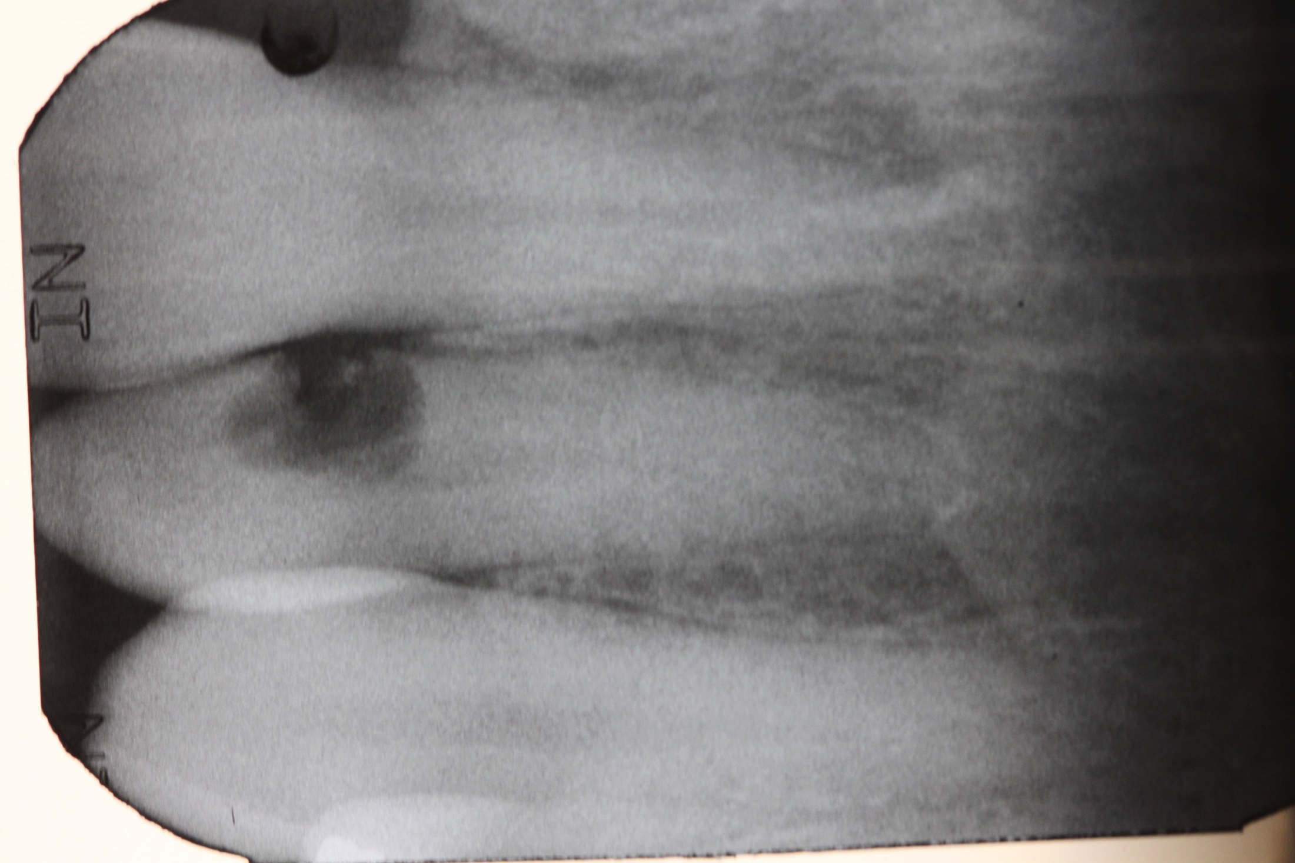 The first x-ray shows a tooth with a large hole

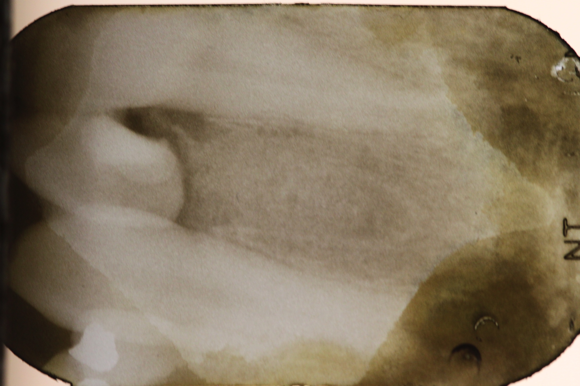

The second x-ray shows the tooth extracted, socket graft undertaken, followed by placement of a temporary tooth

**Healing of the gums at 2 months A bridge placed to replace the missing tooth**

The gums and underlying bone appear similar to

adjacent teeth, with natural emergence & colour

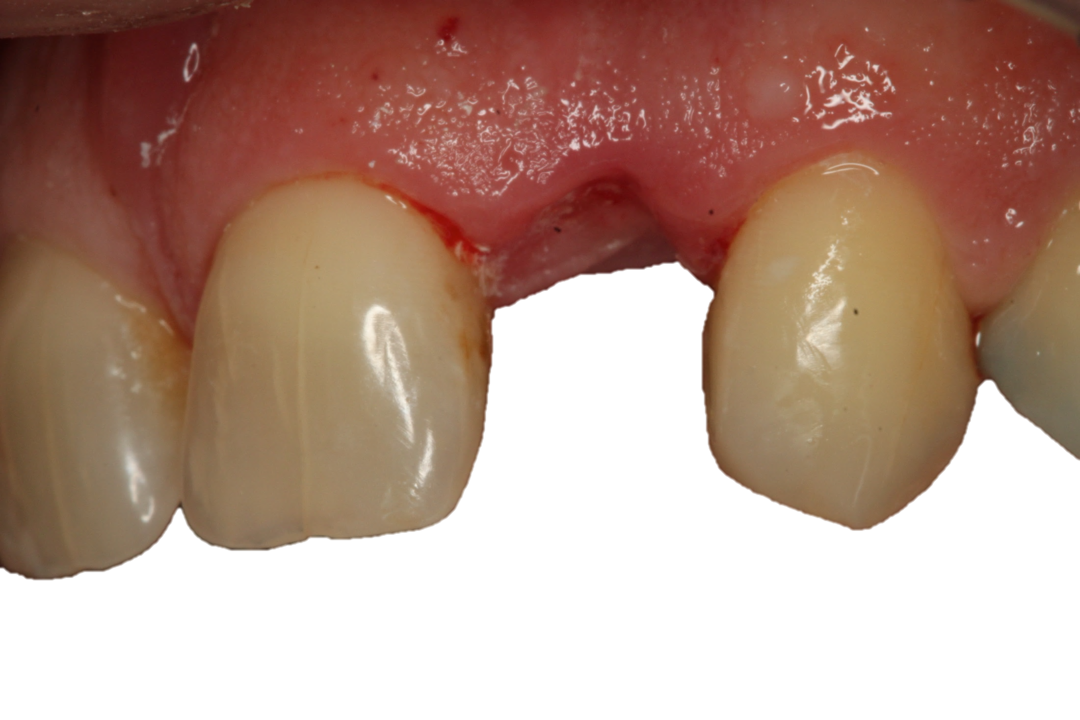 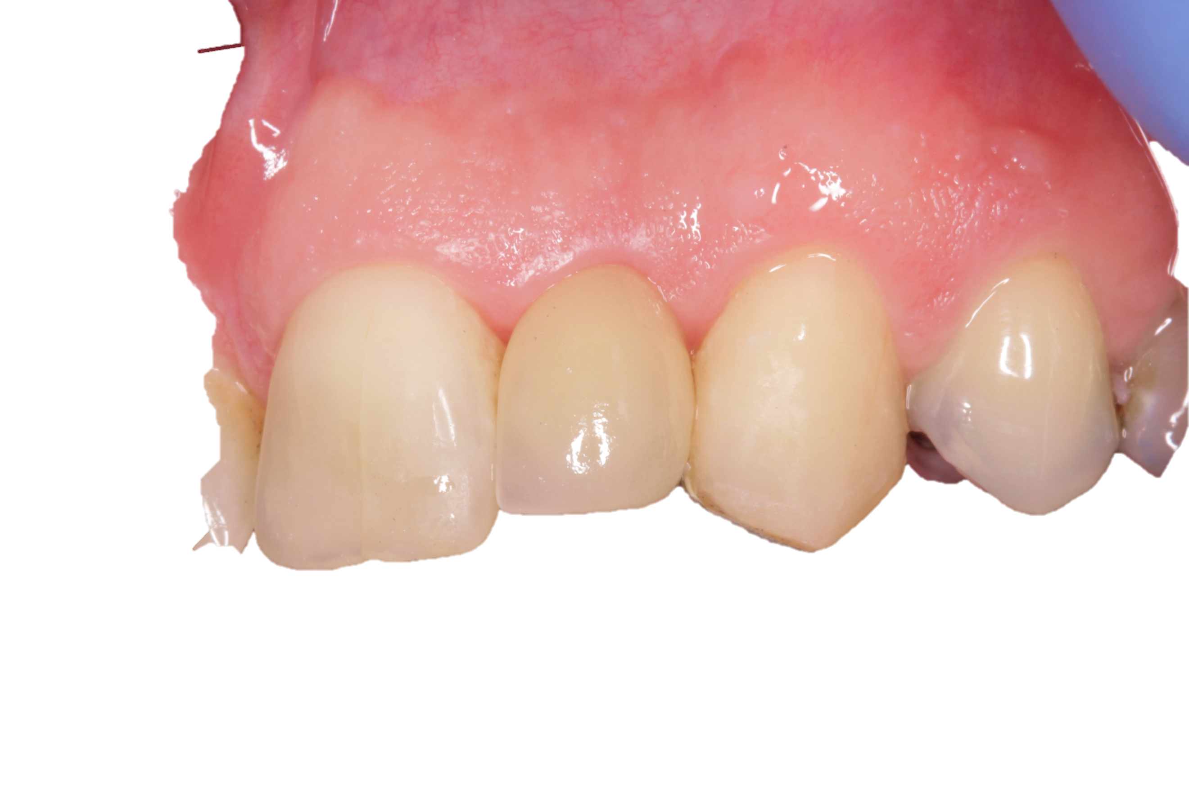

**Here is an example of what can happen to the ridge if you don't undertake socket grafting.**

Bone resorption is a natural sequel to any extraction and can make the it difficult to replace a natural looking prosthetic tooth like bridge or denture (or implant)

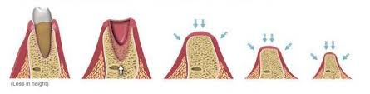

*(image taken from google images for illustration purposes)*

**Post-Operative Care Instructions**

After the procedure, it is crucial to follow these instructions for optimal healing:

* Ice packs:
  + Please use an ice pack 3-4 times a day for the first 5-7 days to help with the swelling, depending on what is practically achievable.
* Analgesics:
  + Please take analgesics 4 times a day for the next 7-10 days
  + Taking analgesics intermittently may take longer to resolve any pain and we therefore recommend talking these regularly
  + Paracetamol (2x500mg [1g] ) combined with Nurofen/ibuprofen (400mg) taken 4 times a day is proven to be very effective at controlling pain. You should not take these medications if your medical history or medications prevent you from taking these. Please do ask us or your GP for any clarifications if unsure.
  + You should only stop the analgesics on the morning you wake up when you don't experience any pain.
* Antibiotics
  + Please take antibiotics as prescribed.
* Warm salt water rinses:
  + This should only start 24-hours after the extraction, and should not be swished forcefully around.
  + Hold the warm salt water mouthwash around the extraction site for 2 minutes before gently dribbling it out.
  + Use the salt water mouth washes 3-5 times a day for the next 7-10 days, depending on what is practically achievable
* Oral Hygiene: Keep the surgical area clean and avoid disturbing the graft site.
  + You should brush all your other teeth as normal.
  + First 10 days: Avoid brushing the area of extraction and bone graft for a period of 10 days. You can use a cotton bud dipped in mouth wash to gently sweep and clean the area
  + After 10-days, A soft (baby) tooth brush can be gently used to keep the area clean
  + After 20-days and once all stitches have been removed, you can resume to clean normally with your electric tooth brush
* Medication: Take all prescribed medications as directed.
* Diet: Follow a soft diet for the first few days and avoid chewing on the surgical side.
* Activity: Limit physical activity and avoid strenuous exercise for at least 48 hours post-procedure.
* Follow-Up Appointments: Attend all scheduled follow-up visits to monitor healing and progress.

**Concluding remarks**

I hope the above information has helped in understanding the plan going forward. **Kindly please return a signed copy of the attached consent form to our lovely reception team prior to your next appointment.**

Please do not hesitate to contact us if you have any questions or concerns regarding the next appointment or any other aspect of your dental care. Thank you for entrusting us with your dental care, and we look forward to assisting you in achieving and maintaining your oral health.

Kind regards,

***Dentist Name***

***Qualifications***

**Consent Form for Extraction and Socket Grafting**

**Procedure**: as outlined in the letter above

**Nature of the Procedure:**

The appointments may include, but is not limited to, the following procedures:

* Visual examination of the tooth.
* Diagnostic imaging, such as x-rays or other imaging modalities (if not already carried out).
* Pulp tests (to assess if tooth nerve is alive or not).
* Evaluation and removal/dismantling of existing dental restorations.
* Assessment of the structural integrity of the tooth.
* Examination of the surrounding tissues.
* Procedure to be carried out under local anaesthetic.

**Benefits of Socket Grafting:**

* As described in the letter above.

**Risks of Treatment:**

* As described in the letter above

**Financial Responsibility:** I have been informed of the estimated costs, and I agree to make payment as required by the dental practice. I understand should I require additional work in the future, there will associated costs with any further treatment required,

**Questions and Concerns:** I have had the opportunity to ask questions and my questions have been answered to my satisfaction.

**Consent:**

* I have read and understand the information provided in this consent form.
* I consent to undergo the treatment as described above.
* I understand:
  + I have the right to change my mind at any time, even after signing this form.
  + The risks of the procedure, alternative treatments, and the consequences of doing nothing have been explained.
  + I have been given a copy of this consent form and have had sufficient time to give my informed consent.
  + I must follow any post-operative instructions given to me.
  + By attending appointments and allowing treatment to be carried out shows I have consented to treatment.
  + I voluntarily accept the risks, including the risks of substantial harm if any that may be associated with any phase of this treatment in hopes of obtaining the desired outcome.
  + I have the right to seek a second opinion from another dentist at any time.
  + I understand that Dentistry is not an exact science and that, therefore, a reputable doctor cannot guarantee any specific results. No Guarantee or assurance has been given by my dentist of the expectations of results that may be achieved.

***Patient’s Signature:*** *................................................................. Date.....................................*